16 BIT MULTIPLICATION

EXP NO :7

AIM : To write an assembly language program to implement 16 bit multiplication using 8085 processor.

ALGORITHM:

1. Start the program by loading the first data into the accumulator.
2. Move the data to a register.
3. Get the second data and load it into the accumulator.
4. Add the two register content.
5. Check for carry.
6. Store the value of sum and carry in the memory location .
7. Halt

PROGRAM:

LDA 8500

MOV B,A

LDA 8501

MVI C,00

LOOP: CMP B

JC LOOP1

SUB B

INR C

JMP LOOP

LOOP1: STA 8502

MOV A,C

STA 8503

RST 1

INPUT:

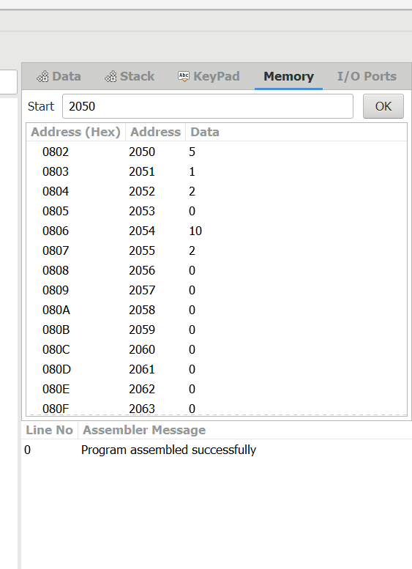

OUTPUT:

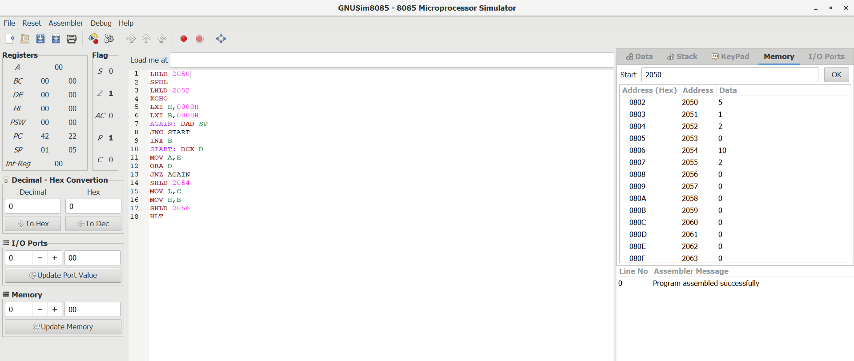

RESULT:

Thus the program was executed successfully by using 8085 processor simulator.